­

Angel Axson – G00330573

Polina Prinii – G00338663

Tatjana Zommere – G00318193

Planet Health

Gym Database

Data Modelling

Database Specification

Contents

Details of the Business 2

Purpose of the Database 3

Mission Statement 3

Objectives of the Database 3

Business Rules 4

Preliminary Entity Relationship Diagram 4

List of Entities and Attributes 5

Normalisation Tables 5

List of Fully Normalised Tables 7

Revised Entity Relationship Diagram 8

Database Constraints 8

Queries and Reports 8

Interfaces 9

Project Time Management 9

# Details of the Business

Planet Health Club is an affordable and easy to use gym with three branches located in Galway, Limerick and Cork.

Each branch is equipped with various facilities.

Within the three branches you have your typical facilities such as Sauna, Cardio Room, Weight Machines, Free Weights and Cable Strength area.

With Limerick and Cork having a Swimming pool each as an extra facility.

A branch can have many employees and each staff member can work in one branch only, but have the possibility of a transfer after 6 months. A branch employs people with gym and fitness knowledge along with some being Personal Trainers. All staff members are identified by staff ID. The position of the staff distinguishes who in the workforce is a manager, personal trainer etc.

A Personal Trainer can work with many members while a member can only have one Personal Trainer.

A staff member is assigned to supervise a facility in the given branch, to make sure things such as capacity is within the maximum along with equipment being up to maintenance and used fairly. A facility supervisor can supervise up to 3 facilities, at a given time, a facility can only have one supervisor.

A member can join only one branch and be able to use that branch only, but a branch can have many members. Each branch offers different Membership types. To register in a branch a member upon joining must pay a once off Registration fee of €20

|  |  |  |
| --- | --- | --- |
| Galway Membership Type | Limerick Membership Type | Cork Membership Type |
| Monthly Membership of €29pm | Monthly Full Membership of €39 | Full Student Membership of €33pm |
| 3 Months Membership of €119 | Monthly Couple Membership of €69 | Full Membership is available for €39pm |
| 6 Months Membership of €189 | Over 70 Membership of €20 | Full Couple Membership for €69pm |
| 1 Year Membership of €259 |  |  |

All members can either pay upfront by cash/card, or set up direct debit.

Each member can undertake any of the classes offered during a week at different times. There are 3 types of class levels: beginner, medium and advanced, the member does not need to enrol in a class, the classes operate on a first come first get basis. There is a limit of participants to each room per class session. A class teacher is usually a Personal Trainer, a PT can teach many classes a week and a class can only have one PT or may not have a trainer at all and. The classes take place within one of the facilities and a facility can host many classes. A class will run only if there are more than 1 member attending.

Each facility is equipped with sport & training equipment in each branch. All equipment is marked with a 4-digit serial number.

All equipment is classified into specific type and is assigned a unique 5-digit number, each piece of equipment has a recommended maintenance time from the manufacturer and is checked regularly. Along with the 5-digit number the equipment type is marked with a 2-letter Manufacturers ID. Each Manufacturer provides the branches with a name, number and address along with a recommended maintenance of the equipment.

# Purpose of the Database

The purpose of this database is to store and when needed to extract information in relation to staff that is employed, member that join the gym and equipment that is brought into the building, along with keeping track of manufacturers that supply such equipment.

This database will be a collection of organized information that will easily allow to be accessed, managed and updated. By creating such a database, data or information will avoid being repeated and from becoming redundant. This will help keep track of staff in terms of who is new, who left, who got fired and who is getting transferred to another branch, along with keeping track of members to see who is active or not.

# Mission Statement

To positively change people’s lives by providing the ultimate fitness experience. Change your body. Change your life.

# Objectives of the Database

Data is a vital company resource, which is important for overall business success and needs to be maintained like other important company assets. Professionally organised database in the organisation is providing the basis for the effective facilities and equipment maintenance, as also is helping to keep track of the employees and customers details, which leads to a competitive advantage on the market. Main objectives of the database are:

1. Provide the efficient storage of the customers and employees details, and also easy update and retrieval of data.
2. Provide high integrity of the company details to facilitate the user confidence for the data usage.
3. Be adaptable to any new and unexpected business requirements and developments.
4. Provide any inquiry and reporting capability for any business area, like financial management, health & safety management, marketing and customer service departments.
5. Keep effective relationships and maintain the channels with external environment, such as suppliers and manufacturers of the gym equipment.

# Business Rules

* A member can join one branch only and have access to the one branch they are registered to.
* Each branch offers different membership types. But a member must choose only one membership type at a time.
* Only Limerick and Cork branch is equipped with a swimming pool
* Each staff member can work in one branch at a time. If they wish to transfer to a different branch, they can request for a transfer in 6 months.
* A personal trainer can work with many members, but a member can only have one personal trainer.
* Each piece of equipment undertakes check-up every three months. And each equipment has a recommended oiling maintenance.
* A facility needs supervisors, and one supervisor can only supervise up to three rooms.
* When a member registers they need to set up a payment method. A member can either pay upfront or set up direct debit.
* All membership is monthly based unless stated otherwise.
* Members joining must be over the age of 16.

# Preliminary Entity Relationship Diagram

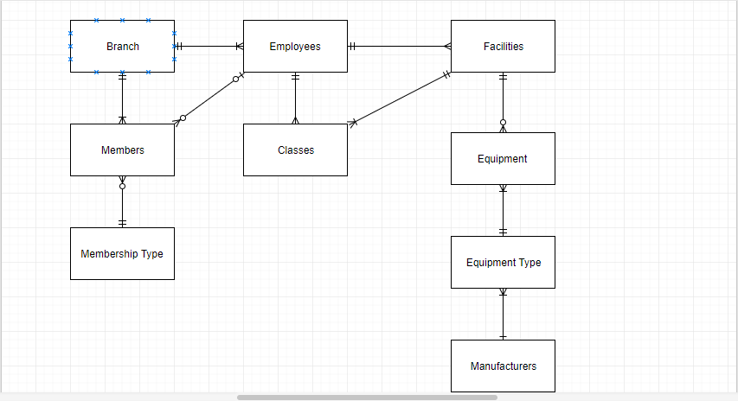

# List of Entities and Attributes

**Branch** **Employees** **Members**

-Branch ID (PK)

-Name -Employees ID (PK) -Member ID (PK)

-Location -Branch ID (FK) -F. Name

-Address -Position -L. Name

-Postcode -F. Name -D. O. B

-L. Name - Contact Info

-Contact Info - Address

**Membership** -Address -Email

-Postcode -Membership ID (FK)

-Membership ID (PK) -Start-date -Payment Method

-Membership Type -Salary -Fitness Level

-Duration -Emergency Contact -Start-date

-Membership Cost -Member Status

-Emergency Contact

-Branch ID (FK)

**Facilities** **Equipment**

-Facility ID (PK) **Classes** -Equipment serial no (PK)

-Branch ID (FK) -Class ID (PK) -Purchase date

-Facility Name -Class title -Date of last maintenance

-Room No -Start time

-Size limit -End Time **Manufacturer**

-Supervisor ID (FK) -Day

-Size limit -Manufacturer ID (PK)

-Trainer ID (FK) -Location

-Facility (FK) -Name

**Equipment Type** -Phone no

-Code (PK)

-Description

-Manufacturer Model (FK)

-Recommended maintenance

# Normalisation Tables

**First Normal Form**

In First Normal Form we search through each table and see if there are any repeating groups and to make sure that each column contains only one unique value. We have found that in our database, First Normal Form applies only to the fields that contain address in some tables as it contains more than ONE value.

For this reason, we can apply First Normal Norm by breaking it down to **Area, Street Name, City** in the Branch Table.

Employees Table and Members Table has been broken down to **House, Street Name, City.**

Branch Table before and after Normalisation

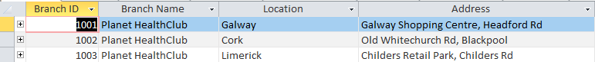

Members Table before and after Normalisation

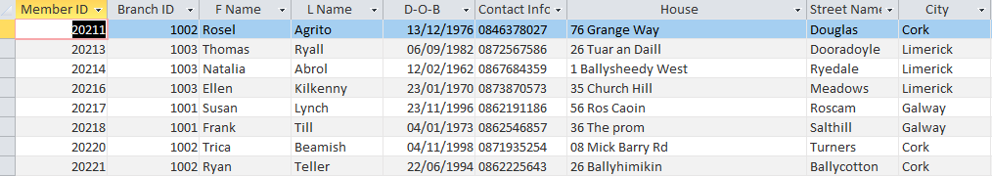

Employees Table before and after Normalisation

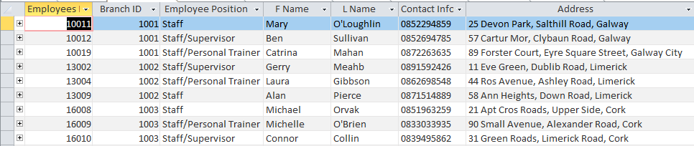

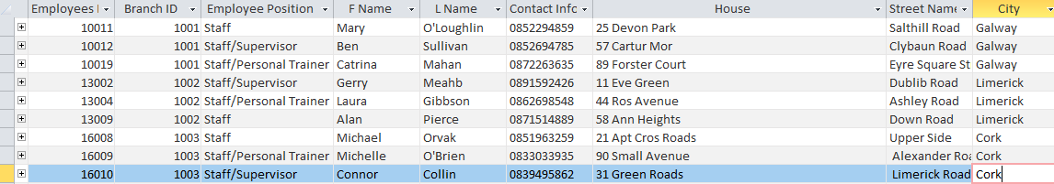

**Second Normal Form**

**In Second Normal Form we check to see if the columns which are non-primary keys are only and fully dependant on the set primary key within the table. After analysing all the tables, we have concluded that all our non-primary key columns are indeed only dependant on one primary key. For this reason, the tables are automatically in Second Normal Form as our tables all have only one primary key.**

**Third Normal Form**

**In Third Normal Form we check to see if all non-key columns are dependent on other non-key columns, if they are, we must put them to separate tables and assign primary keys for relationships. After undertaking an analysis on our tables, we have identified that all are non-key columns in each of the tables are independent of other non-key columns, making our tables automatically be in Third Normal Form.**

# **List of Fully Normalised Tables**

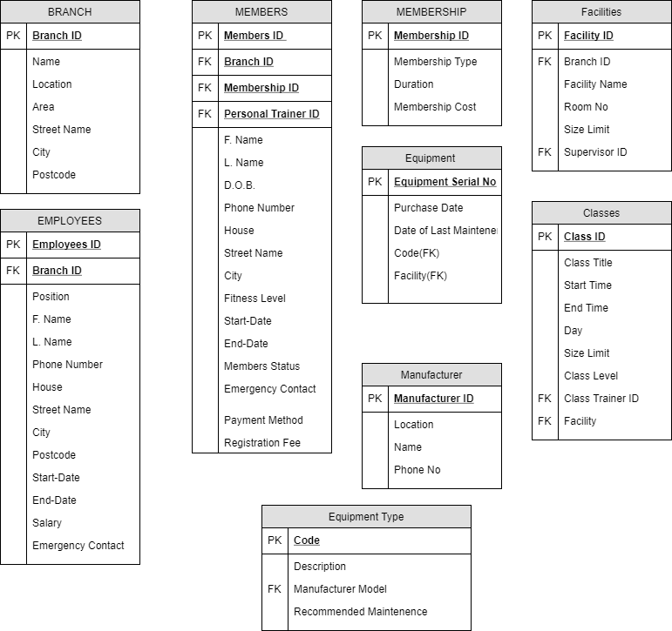

# **Revised Entity Relationship Diagram**

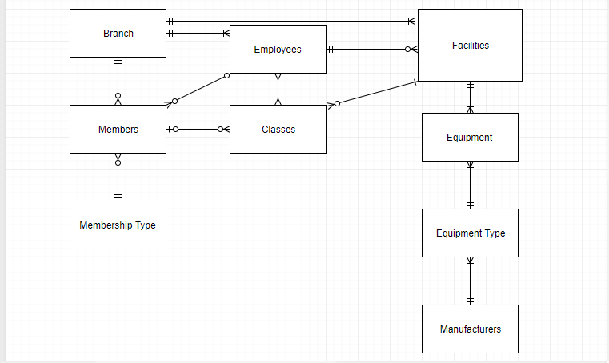

# Database Constraints

1. Branch Table: Postcode should not be more than 6 characters (4 digits and 2 letters), so we have changed the field size to 6, input mask 0000LL, which means that the user must input 4 digits and 2 letters.

2. Members Table: Member should be 16 or over years old to join the club, so we have put in D.O.B field a Validation Rule <#01/11/2001#, this states that if a user tries to enter a D.O.B over the 1st of November 2001, it will show the error message: “Member has to be 16 or over”.

3. Members Table: Phone Number should be 10 digits only and in format (086) 123 4567, so we have put the input mask (000) 000 0000.

4. Classes Table: Class can’t start before 6am and finish later than 8pm, so we have put Start Time and End Time format to Short Time and added a Validation Rules for Start Time is >#06:30:00, End Time is <#20:00:00.

5. Employees Table: Phone Number should be 10 digits only and in format (086) 123 4567, so we have put the input mask (000) 000 0000. We also added an Input Mask on the Postcode input mask 0000LL, which means that the user must input 4 digits and 2 letters.

# Queries and Reports

We have created 3 sample queries and 3 reports to run them:

**1.** **Employees by Salary**, which allows the user to set criteria between the max and min salary values and see the number of employees within the chosen salary range. We have also created a report to run this query.

**2.** **Employees by Branch**, which allows the user to create a list of all employees working in one branch. And, also to create a report by running this query.

**3.** **Equipment by Manufacturer**, which allows the user to create a list of all equipment, produced by one manufacturer. We have applied a wildcard in the criteria to make it easier to use the query even if you don’t remember the full name of the manufacturer, you still will get a result. We have also created a report to run this query.

# Interfaces

We have set an Interfaces, that the user will see Members form first when open the Database, and in Navigation Pane we have hided the tables, so the user can only use forms, queries and reports.

# Project Time Management

Our team has been working for 3 weeks on the project, and each group member has equally contributed into the work process.

We didn’t measure the time spend on each element of the project exactly, as sometimes it was difficult to control it and keep count of how much time each of us spent on same, because we tried to work together as a team most of the time.

We have created the database together and each team member has equally participated in every step of the project, so that each team member was able to take part in the process and learn something new from it.